DEPARTMENT OF MATHEMATICS
SENIOR SIX MOCK EXAMINATIONS JULY/AUG 2013
PAPER ONE(PURE MATHEMATICS) P425/1
TIME: 3 HOURS
INSTRUCTIONS;
- Attempt all the questions in section A and ONLY five questions in section B.
- Any extra questions attempted will not be marked.
- All the necessary working must be clearly shown.
- Indicate clearly in a grid the questions you have attempted.
SECTION A (40 MARKS)
1. Solve the equation 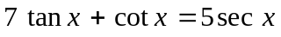 for 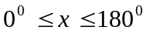. (5 marks)
2. Find the circumcentre of the triangle with vertices 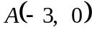, 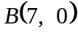, 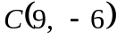. (5 marks)
3. Show that if 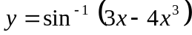, then 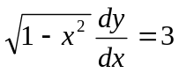. (5 marks)
4. The points A,B and C have position vectors 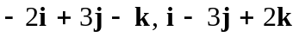and 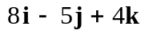respectively.
(i) Find the coordinates of the point M which divides AB externally in the ratio 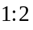.
(ii) Determine the coordinates of D if ABCD is a parallelogram. (5 marks)
5. Find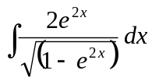. (5 marks)
6. The sum of the first twenty terms of an arithmetic progression is 800 and the sum of the first twenty six terms is 1352. Determine the first term and the twenty third term. (5marks)
7. A polynomial leaves a remainder of 7 when divided by 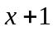 and a remainder -8 when divided by 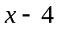. Find the remainder when it is divided by 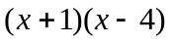. (5 marks)
8. Solve the differential equation 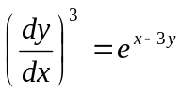, given that 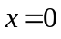when 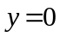. (5marks)
SECTION B: 60 MARKS
9a) The angles of a triangle are in a geometric progression. If the smallest angle is 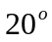, determine the largest angle. (5 marks)
b) Expand 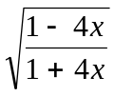in ascending powers of 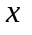as far as the term in 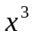. Hence evaluate 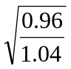correct to three significant figures. (7 marks)
10a) Determine the perpendicular distance of the point 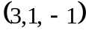from the line
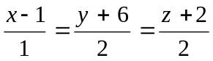. (5 marks)
b) A plane β is perpendicular to the vector 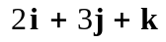and contains point A with
position vector 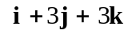. Find the position vector of the point where the line 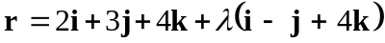meets β. (7 marks)
11. Evaluate 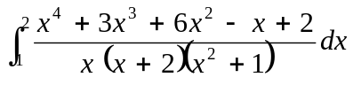. (12 marks)
12a) Without using tables or a calculator, show that 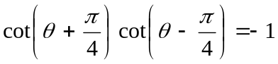.
(5 marks)
b) In a triangle, prove that, if the internal bisector of  meets  at , then 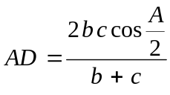. (7 marks)
13. A curve is given by 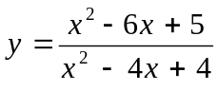 .
(a) Find the range of values of for which the curve does not exist. (3)
(b) Sketch the curve. (9 marks)
14a) Find the real values of and such that 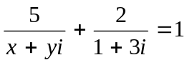. (6 marks)
b) Determine the cube root of 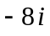. (6 marks)
15a) Find the Cartesian equation of the locus of the point 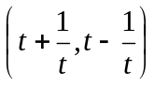 (4 marks)
b) Given that the line 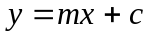 is a tangent to the ellipse 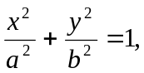 show that 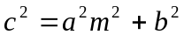. Hence, determine the equations of the tangents at the point 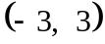 to the ellipse 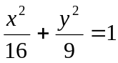. (8 marks)
16a) Solve the differential equation 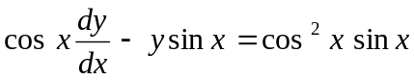. (5 marks)
b) The displacement of a particle at time t is , measured from a fixed point and 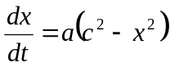, where a and c are positive constants, and 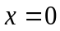 when 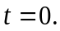 Prove that 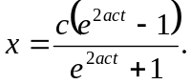 If 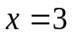 when 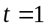 and 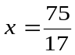 when 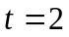, prove that 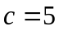 and find the value of (7 marks)

END

